Facial Recognition for Airport Security

In the matter of safety, it is always good to be safe than sorry

### An intro to Air travel

The aviation industry is colossal in its presence serving more than 4.5 billion passengers every year and giving livelihood to more than 25 million people in a year. The safety of this sector has come to the forefront as the Aviation Industry has always been an easy target for attacks by international/domestic or extremist groups. With the looming 20th anniversary of 9/11 attacks still on the horizon next year, we can be assured the importance of security at airports to be of paramount importance now more than ever.

### About Us

Our firm XYZ, a technological endeavour and part of the prestigious XYZ group, has always made a priority of safety with our custom market-ready cybersecurity products. The XYZ technical ecosystem focuses on providing innovative answers for digital dilemmas of now. We are equipped to surpass and excel the matters of the fourth industrial revolution with a superior technological presence that envelops Modern technologies like Blockchain and IoT(Internet of things).

### The technology behind our latest product

Our main aim here is to leverage biometrics and employ it as an asset to existing real-time video analytics wherein we use cameras as tools. Consider every single computer with a digital camera around you to be an eye looking on, storing information, identifying and processing images similar to the human eye, and slowly understanding the visual world. We are at the point where Robots have human-like recognition capabilities. This feature is automated for detecting data patterns and interacting with efficiency.

In our product application, we used the available video surveillance system in airports to our benefit, providing us with a leg up by using existing infrastructure. The many cameras in the surveillance system provide raw data feed with the faces of passengers who enter and exit the airport.

The data is analysed using DSP(Digital Signal Processing) and Computer Vision with Deep Learning(part of the Machine learning paradigm) to trace the facial patterns after data collection. Artificial systems are now trained to mimic human reactions in images and even interpret them.

### Advantage of using a real-time video feed

Videos are important as they convey more information, they pack in a lot more information in comparison with a mere picture. Tracking an object/person is easily done in a video but impossible through a picture. There are obvious cons to using video analytics with Computer Vision. They are data storage and data processing. But we are at the point where processing power and storage can meet the threshold for this tech to work.

### A product for the times

The main aim of our product was to enhance security by adding specific features to surveillance and pushing the envelope in a new direction.

The feature list included Firstly, decreasing time at the checking and verification counter by using biometrics instead of the third-party intervention thereby reducing enhancing passenger experience for time flyers.

Secondly, Our use of existing infrastructure made sure that cost will be minimal without many changes, it also made sure that security is increased without growing the strength of the airport security staff.

Thirdly, This system will support the current manual process and expand digital transformation by option for future development and improved efficiency that is an added benefit in the long run.

Fourthly, This product will assist the security staff in minimizing human error and be able to recognize them as and when they appear therein improving productivity and competence.

Lastly, The success of this product will enable us to apply it wherever we please in a similar commercial setting like in Bus terminals, municipal offices, governmental areas, terrorist prone places and in times of dire threats or to find criminals in our midst.

### A real-time use case

To understand any system with clarity, it is important to place it in a real-life scenario, so we give you a closer look at how our implementation works.

**Face Tracking**

The video stream is shared in our system and faces are recognized and tagged. These are then identified and compared using specialised biometrics with faces in our present database.

**Personal Identification**

From there each person is identified with their name and unique identity.

**Storage and analyzes**

After identification, the system alerts and tracks individuals at other events and checks for malicious activity and blacklists any leads.

**Advanced recognition**

Our modern features employ a multipronged approach with recognition extended to an industry first, partially covered faces.



With the advent of covid 19 and people wearing masks, it is an important feature to be included as it makes it advance to the future.

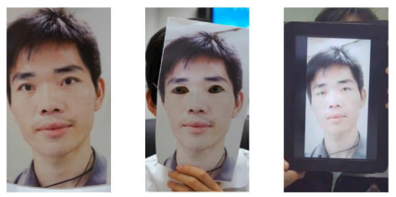

Second, the ability to differentiate live faces from fake ones. We can use this when and if any suspicious individuals try to cheat the system.

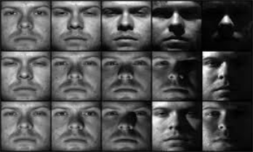

Third, overcoming bad lighting conditions to present a better result, as we can not always be sure that all corners of an airport will be well lit and provide better results in case of any rising eventualities.

**Notification**

If there are any questionable identities found in the database these individuals are tagged and then their faces are forwarded to the airport security staff and customs.

**Aid in the reduction of reaction time**

By the application of this system, it reduces our reaction time manifold thereby reducing the pressure on the ground airport staff and easing tensions of frequent and first-time flyers.

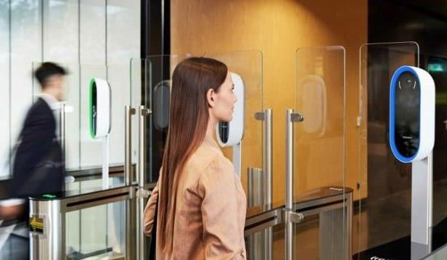

**Free Hands**

With our failsafe biometrics system, customers will not need to carry their passes in their hands. Identification takes place exclusively via technical means. Combination of passenger profile with a biometric profile of a person ensures online check-In by adding a photo when registering via a mobile or web application. Another possibility of use is at the counter reception, where taking pictures for instant authorisation gets you through.

A different use case is at the terminal where photography enables automatic registration. For Domestic Flights, we can enable identity confirmation using the face image.

**Bonus of safety**

Safety is a necessity, not a luxury, people always choose to be safe and are willing to pay a little bit extra to be safe. Our system ensures safety and will be useful to attract prospective customers to airports everywhere.

### Advantages to the Airport setting

* Our system enables Identity check at the boarding gate initially.
* Eliminates the risk of transferring the boarding pass to any unauthorized person.
* Gates are equipped with electronic boarding passes using facial biometrics thereby reducing human intervention that could lead to error or ambiguity.
* The automatic tracking of passenger movements at the airport reduces pressure on airport security and is a more efficient method.

### An Industry Game changer

The product provides measurable results that make for huge success. Our success lies in our initial tests wherein:

1. We observed a **98% success rate** in real conditions where our system identified and traced some faces from others.
2. **100% of all faces** were identified in a continuous video stream.
3. The time taken to match individual faces was a mere **3 seconds** for identification
4. Only **3 seconds** were required to parse through a 1 million sample size database.
5. The ability of the system to identify **15 faces** at a time through a video feed.